Shabbos Stories for
Parshas vayeilech 5780
Volume 11, Issue 2 6 Tishrei/ October 5, 2019
Printed L’illuy nishmas Nechama bas R’ Noach, a”h

For a free subscription, please forward your request to keren18@juno.com

Results of a Kind Gesture



Reb M. Y. Horowitz Shlita, av beis din of Linsk, Boro Park, took out his cell phone, chose the "contacts feature” and pressed on one of the 23 names. Immediately he realized he made a mistake.
He accidentally called someone else with the same last name as the person he was trying to call. He decided he should let the call go through, just so he could hear how this man was doing.
The person whom he accidentally called davens in his beis medresh. He was divorced, and at the time of this phone call, he was in Europe for the summer vacation.
Reb Horowitz greeted him warmly and asked how he was. The man was startled.
“It can’t be that you called just to ask me how I am.”
Reb Horowitz insisted that he just wanted to hear how he was.
The next time they met in Boro Park, the man said to Reb Horowitz, “You can’t imagine how much you helped me with your phone call. You know that I'm alone in the world, and you know I'm at a low level, spiritual-wise. When you called, I was in a hotel in Italy, at the gateway to Gehinom, ready to commit the worst.
“And then you called, just to ask how I am. I felt you blew life into me. I felt someone cares about me. This protected me from sinning…”
This story happened three years ago. Today, this man has remarried and is building a bayis ne’eman beYisrael. Let us learn from this story the following points:
(1) Those who are involved in kiruv shouldn’t feel they aren’t succeeding. Sometimes, even a simple phone call can save a person’s life. Remember: One can be accomplishing a lot even when he isn’t aware of it.
(2) Learn from this story how much Hashem strives to save those who have fallen to low levels. Even at the gateway of Gehinom, Hashem seeks to save him. (3) A timely phone call was just what this man needed. This is a reminder that Hakadosh Baruch Hu leads the world with hashgachah pratis. Everything is perfectly arranged.
(4) And this story is a reminder of the power of a kind word. How far it goes. How much it does for a person. Encouragement People can reach very high levels, but they need support. They need to hear that they are on the right path and that they can succeed. They need to hear an encouraging word, and then they will reach their potential.

Reprinted from the Parshas Eikev 5779 email of Torah Wellsprings: Collected Thoughts fromRabbi Elimelech Bidernan

The Money Benefits of Guarding One’s Eyes

A poor Yid from Yerushalim came to Monsey, New York, and collected money for his family. Before returning back to Yerushalayim, he called up one of his friends from Boro Park, and told him that he would be soon returning to Yerushalayim.
The friend told him, “Prolong your ticket for four days and I will go with you to wealthy baalei tzedakah in Boro Park.”
The Yerushalmi Yid wasn’t sure he wanted to prolong his trip. His family wanted him back home.
“How much money do you think we can make in four days?”
“Five thousand dollars, at least.”
“For five thousand dollars, it's worth to prolong the ticket.”
They made up that to meet Sunday morning in Boro Park. Over Shabbos, this Yerushalmi yungerman read a booklet that discusses the importance of guarding the eyes. He read that for being cautious, one gets parnassah easily and abundantly. And if one isn’t cautious, he loses the bounty of parnassah that was destined for him.



The Yerushalmi Yid thought, “It wasn’t by chance that I read this. It is a sign that I must be cautious with my eyes. In this merit I will earn my parnassah easily…”
On Sunday morning as he got ready to take the bus to Boro Park, he remembered that the bus passes through Manhattan. He knew he would be tempted to look out the window to see the magnificent buildings and the busy streets. But he was resolved to guard his eyes. So he put his eyeglasses into his suitcase and put the suitcase in the baggage compartment under the bus.
He arrived in Boro Park, hopeful that having passed the test, Hashem will grant him parnassah easily. His friend met him at the bus stop and said, “I was thinking about it. I decided you don’t have to come with me to collect money. Why should you belittle yourself? I will collect for you. I promise, I will send you $25,000.”
The hashgachah pratis was evident. As he was guarding his eyes on the bus, his friend decided to help him earn his parnassah in an easier and more honorable way! Because when one is cautious with his kedushah, he will earn his parnassah in an easier way, and with a greater abundance.

Reprinted from the Parshas Eikev 5779 email of Torah Wellsprings: Collected Thoughts fromRabbi Elimelech Bidernan

The Man Who
Trusted in Hashem

This happened on my wedding day, moments before they were bringing me under the chuppah. My father zt”l took me to the side and wanted to tell me a story but not before he made me promise not to repeat it to anyone especially since it happened to him.



After I gave him my word, this is what he told me: This was during the early years of the establishment of the State of Israel (1949-1950) when there was a famine in Yerushalayim, and the tormentors of Israel closed the approaches to Yerushalayim and there wasn’t enough commerce and food.
My father was one of the milkmen in Yerushalayim and despite having the resources to buy food, since supplies were not reaching the city, there was nothing to eat. My father utilized every moment to learn Torah and even in the house he was bent over his studies.
Mother turned to him and said that the children are very hungry. He lifted his eyes from the holy Gemara and kindly told her to say Tehillim. The righteous mother did as she was asked, but a short time later she told him that the children are hungry, and they can’t sleep because of the hunger!!!
When he heard that they could not sleep because of hunger he said, “I will go up to shul to say Tehillim.” He went up to the floor above the apartment where there was a small shul and he began to say Tehillim with warmth and feeling. This was at about midnight.
Not long after, two men came and knocked on the door by my mother. Mother was scared and asked through the trellis, ‘Who’s there and what do you want at this late hour in the middle of the night?’
Because of her fear, she sent them up to the shul. They asked Father to come with them. Father went down with them and saw two large crates. They said they were sent by family members overseas to bring these crates. He pushed the two heavy crates into the house, and he turned to thank them, but they were already gone.
The two crates were filled with canned food and all types of goodies. There was enough to sustain the family for many months!!! Father tried to locate the relatives that sent the crates of food, but no relative, near or far, knew what he was talking about.
Father finished the story and said: “I am telling you the story to teach you one thing: If you trust in Hashem, you will not lose a thing!!! Now you are entering the chuppah, it is important to me to tell you this to strengthen bitachon in Hashem and He will bless you abundantly!!!

Reprinted from the Parshas Eikev 5779 email of Tiv Hakehila.

Beautiful Blue Eyes
By Rabbi Yechiel Spero

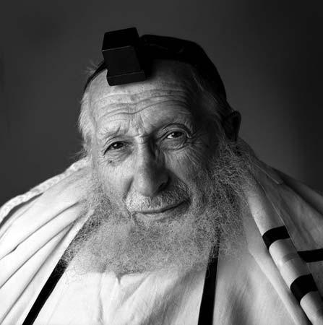
4
Rav Chaim Pinchas Scheinberg zt”l was once approached by a woman whose husband had hepatitis. While he wasn’t deathly ill, he was significantly struggling. The woman as well was having a particularly difficult time, given the amount of work she needed to take on to attend to the family’s needs nearly single-handedly.
As she began detailing her predicament to Rav Scheinberg, it became evident that not only was she having a hard time due to her husband’s condition and the resulting increase in housework, but because one of her children was slowly becoming less and less religious. It was a sure cause of distress and anxiety for her, and the woman did not know what to do.
Rav Scheinberg did not hesitate to tell the woman that he would like to come and visit her husband. The woman tried convincing Rav Scheinberg out of it, as she knew he was very busy and juggling many responsibilities, yet he did not take no for an answer.
When Rav Scheinberg arrived at the house, the woman made a special effort to ensure that all of her children were home to greet the renowned gadol. The woman introduced her children, as Rav Scheinberg went from one to another greeting them and sharing some pleasant words.
Yet when Rav Scheinberg came to greet the boy who was evidently having difficulty and was becoming more and more irreligious, he took hold of his hands, looked him in the eyes and said, “Has anyone ever told you that you have beautiful blue eyes”?
“My son’s return to Yiddishkeit didn’t happen overnight,” the woman related, “but what did happen overnight was my own acceptance of who he was, no matter what he would choose to do.
“From that moment on, irrelevant of his decision to keep a life of Torah and mitzvos, all I could see was his beautiful blue eyes and continue to understand him, accept him and believe in him.”

Reprinted from the Parashat Eikev 5779 email of Torah Anytime Newsletter.

Not His Brother

Chaim grew up in a tiny bungalow in Netanya. His father, who worked as a cashier and floor-sweeper in a small grocery store, barely made enough to keep a roof over his family’s head. At 17 Chaim left home, went to work, and eventually saved enough to buy a ticket to America.
There the hard-working young man began to find opportunities. By the time he was 23, he owned his own small business. By his 30th birthday he was living in a beautiful house set back on a sprawling green lawn. Every month, he sent his father $200 and a letter. However, he tried to put his old life behind him. Meanwhile, Chaim’s younger brother Rafi was still stuck in the old neighborhood.
“Go find Chaim,” urged his father. “I’m sure he’ll take you in and get you set up in business.”
Rafi began saving money for his trip. He even began holding out his hand for donations. After more than a year of scrimping, he bought an airline ticket to America. Relying on the generosity of Jews he met in New York, he finally located Chaim in an exclusive neighborhood on Long Island.
Filled with anticipation, he made his way up the grand walkway to the heavy, carved front doors. He rang the bell and waited. A maid opened the door to find a shabbily-dressed Jew with a thick accent, asking for Chaim.
“I’m sorry. He sees charity cases only between 9 and 11 in the evening,” the maid explained.
Rafi smiled. “Tell him please that his brother Rafi is here.”
The maid looked skeptically at the man at the door, but turned to do his bidding. A few long moments later, she came back and stared sternly into the face of the apparent impostor. “He says he has no brother,” the maid stated as she shut the door in Rafi’s face.
Rafi gathered himself up and, realizing that he had nowhere to turn, found his way back to Israel, where he managed to pull together a modest livelihood for himself.
It wasn’t long before Chaim received word from Rafi that their father was ill. “If you want to see him while he is still in this world, come soon,” he wrote. Suddenly, Chaim was filled with longing for his father. He put aside his affairs and booked the next flight to Israel. He took a cab from the airport straight to Netanya and was soon looking incredulously at the hovel that had once been his home.
He knocked on the door and waited. Someone was coming, progressing along in a slow shuffle. At last the door opened and there stood his father, weathered, wilted, and gray.
“Abba!” Chaim said, choked with emotion. “It’s me, your son. I’m here.” The father looked coldly into Chaim’s face. “I have a son named Rafi,” he said. “If he has no brother, then you cannot be my son.”

Reprinted from the parashat Re’eh 5779 email of Oneg Shabbos (London, United Kingdom) Originally published by the Chofetz Chaim Heritage Foundation.

Doctor, Doctor…
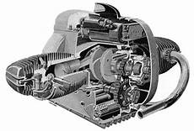
A mechanic was removing a cylinder-head from the motor of a Harley motorcycle when he spotted his cardiologist – Dr. Simon Goldstein in his shop. Dr. Goldstein was there waiting for the service manager to come take a look at his bike when the mechanic shouted across the garage
"Hey Doc, want to take a look at this?"
Goldstein, a bit surprised, walked over to where the mechanic was working on the motorcycle.
The mechanic straightened up, wiped his hands on a rag and asked, "So Doc, look at this engine. I open its heart, take the valves out, repair any damage, and then put them back in, and when I finish, it works just like new."
"So how come I make such a small salary - and you get the really big bucks? You and I are doing basically the same work!"
Dr. Goldstein paused, smiled and leaned over, then whispered to the mechanic, ''Try doing it with the engine running."
Reprinted from the Parshat Re’ei 5779 email of Lekavod Shabbos.

The Big “I”
By Rabbi Lord Jonathan Sacks

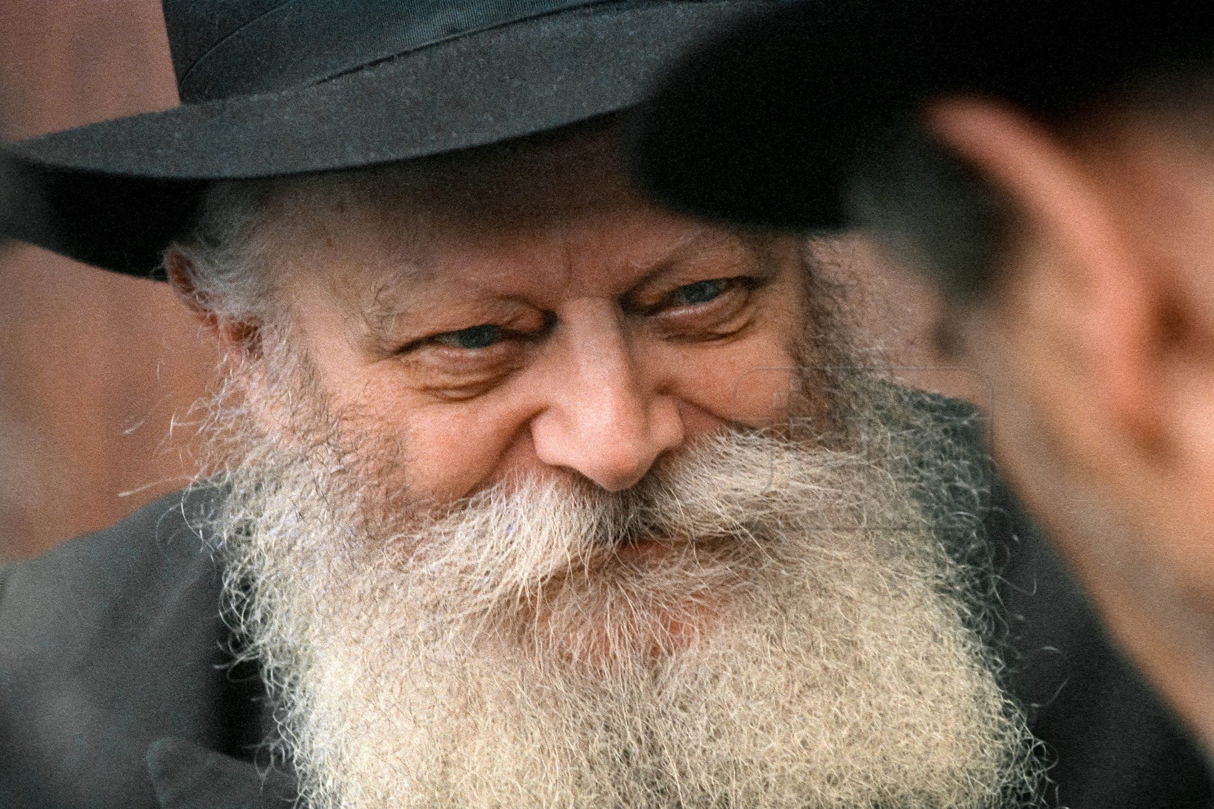

In 1968 I met the Lubavitcher Rebbe, Rabbi Menachem Mendel Schneersohn, of blessed memory, for the first time. While I was there, the Chassidim told me the following story.
A man had written to the Rebbe in roughly these terms: “I am depressed. I am lonely. I feel that life is meaningless. I try to pray, but the words do not come. I keep mitzvot but find no peace of mind. I need the Rebbe’s help.”
The Rebbe sent a brilliant reply without using a single word. He simply circled the first word of every sentence and sent it back to the man.

Reprinted from the Parashat Shoftim 5779 email of Shabbat Shalom fromCyberspace.
Meeting Rav Avrohom Pam
By Tzvi Yaakovson

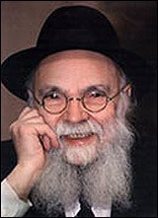

I had visited Rav Avrohom Pam’s home together with Aryeh Deri, in his [Mr. Deri’s] first stint as [Israeli] Minister of the Interior, when he visited America in the year 1990. Deri met with gedolei Yisroelin America and was a guest of the Lakewood Yeshiva, where we traveled by helicopter from Manhattan.
He was also the speaker at the dinner of the Mir Yeshiva and met with the directors of Merrill Lynch, to whom he presented a revolutionary proposal involving the local governments in Israel. At the time, it sounded like a farfetched idea and was not implemented. However, the same idea was adopted 25 years later. But that is not my point.
As the most junior member of Deri’s delegation, I was sent to Rav Pam’s door to find out if the group could come in. Everyone waited in the convoy of cars (which included a security vehicle that had been sent by the Israeli consulate) outside the rosh yeshiva’s home, as I approached the door and rang the bell.
The door was opened by a man whom I took to be Rav Pam’s gabbai or chavrusah, or something of the sort. I explained the reason for my arrival, and he told me to invite the delegation inside.
I delicately asked if he could receive permission from the rov himself, to which he replied, “I am Avrohom Pam.”
I nearly fainted on the spot. I had never imagined that Rav Pam would answer the door, or that he would be wearing an ordinary-looking jacket and would radiate such an unassuming air. For me, that was the most memorable moment of the entire visit.
Years later, I met one of Rav Pam’s sons in a store, and I was struck by his modesty and his mannerisms, which were incredibly reminiscent of his father.
In any event, I consider it an enormous privilege to have met and spoken with Rav Pam.-- Reprinted from the August 28, 2019 email of the Yated Ne’eman
Judging Favorably #52
The New Watch



I needed a new watch and decided to buy it from my neighbor, Avi Baum, who has a small jewelry store. The next day after work I drove over. After a long day, I’m really exhausted, but my schedule is full and there was no other time.
Avi was helpful and in no time I found exactly what I was looking for. I was eager to pay and get home. But when I asked Avi for the price, he told me he’d be with me in a minute – he just wanted to finish up with another customer.
I really wanted to get home, so I walked over and asked him how much I owed for the watch. He smiled and said he’d be with me in a few more minutes, and continued with the customer.
What’s the big deal? I almost said out loud. Tell me the price and let’s just finish this up. Instead, I said, “I’ll give you a check if you don’t have time to take cash, okay?” Then I said more emphatically and impatiently, “Okay, Avi?”
I didn’t hear an “Okay, a check is fine,” as I had hoped to hear, but I saw the other man was finished and Avi was taking his check. Hey, wasn’t I here first? The man left, and Avi turned to me.
“Sorry, Moish, I’d like to give you a twenty-percent discount – but I didn’t want to say it in front of the other customer.” (The Other Side of the Story by Yehudit Samet)

Reprinted from the Parshas Shoftim 5779 email of The Weekly Vort.
SAGES THROUGHT THE AGES
Rav Yonasan Eibeshitz
Cracow, Poland 1690 – Altona, Holstein (Denmark-Norway) 1764
By Dr Benji Schreiber

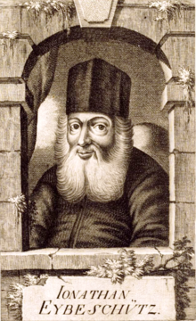

Reb Yonasan Eibeshitz was born in Cracow. His father, Rav Nosson Nota, was Rov in Eibeshitz and died when Reb Yonasan was 15. He was famous as a child prodigy. He learnt in Prossnitz and then in Holleschau. He married Elkele Spira, daughter of Rabbi Isaac Spira, and they lived in Hamburg for two years with Mordecai ha-Kohen, Elkele’s maternal grandfather.
He settled in Prague in 1710 and became rosh yeshiva. The Christians allowed him to reprint the Talmud, omitting any criticism of Christianity and not using the word ‘Talmud’.
He published some volumes including ‘Hilchos Brachos’. After the French conquered Prague he became Rov of Metz in Northeast France in 1741. In 1750, he was elected rabbi of the Three Communities: Altona, Hamburg, and Wandsbek. Stories relate his great genius and quick wit. Here’s an example: Young Yonason was given a few pennies by his father to buy himself a treat on the way home from cheder. As Reb Yonason was walking, the evil non-Jew Ivan walked over to him and slapped him across the face.
Surprisingly Reb Yonasan took the coins from his pocket and presented them to Ivan. The surprised Ivan immediately asked “is this in return for the slap?!” and he burst out laughing. Without blinking Reb Yonason replied “why yes of course! Don’t you know that today is a Jewish holiday which requires us to reward every gentile who harms us with all of our money?!”
Evan just couldn’t believe his ears… this is his lucky day! Quickly he strode over to the famous Jewish rich man and with all due respect handed him a ringing slap. But instead of money the rich person sounded the alarm and Ivan was presented with the beating of his life!

Shabbetai Zvi controversy
Shabbatai Zvi (1626-1676) was a Sefardi Jew who lived in Turkey and claimed to be Mashiach. He was put into prison and eventually converted to Islam rather than being put to death.
Rav Yaakov Emden (1697-1776) – son of Rav Zvi Ashkenazi, the Chacham Zvi - lived in Altona (now Germany) and worked as a printer of seforim. In his Megilat Sefer he publicly accused Rav Yonasan Eibeshitz of being a secret follower of the deceased Shabbatai Zvi, citing amulets that Rav Yonasan Eibeshitz had written.
In 1752 the battle raged and the Gedolim of the generation all got involved. The Nodah BeYehuda, Rav Yechezkel Landau (1713-1797) tried to mediate between the two. The Vilna Gaon (1720-1797) sent his blessings to Rav Yonasan Eibeshitz, and thus attracted sharp criticism from Rav Yaakov Emden.
Rav Yaakov Yehoshua Falk, the Pnei Yehoshua (1680-1756) was opposed to Rav Yonasan Eibeshitz and as a result eventually was forced to leave Frankfurt. Most of the community sided with Rav Yonasan Eibeshitz and even forbade people from attending the shul of Rav Yaakov Emden and he was ordered to leave Altona.
However, the court of Frederick V of Denmark sided with Rav Yaakov Emden, allowing him to return and fining the council of the three communities one hundred thalers (from which ‘dollars’ get their name).
Rav Yonasan Eibeshitz’s younger son, Wolf Jonas Eybeschutz, did declare himself a Shabbatean prophet! However, there is a tradition from the Chasam Sofer (1762-1839) that Wolf did Teshuva later in his life following a dream in which his father appeared to him.

Writings
Rav Yonasan Eibeshitz wrote 98 sefarim, many of which have not been published. Published works include thirty seforim on halacha, including ופלתי כרתי on Shulchan Aruch (the only one published in his lifetime), seforim on Mishne Torah, Shem Olam on Kabbalah and Luchos Edus in which he describes the whole Shabbetai Zvi affair.
In his commentary on Bereishis he has a long technical description of Migdal Bavel as an attempt to get above the clouds and fly to the moon!

Reprinted from the parashat Re’eh 5779 email of Oneg Shabbos (London, United Kingdom)

The “Rabbi’s” Hat

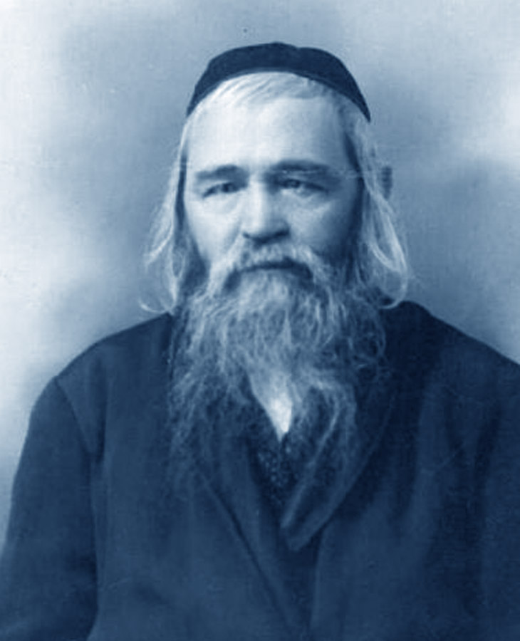

A group arrived at the door of Rav Tzi Pesach Frank, O”BM, the Rav of Jerusalem. They were collecting funds to assist an important Rav who had just immigrated to Israel and couldn’t afford to purchase Rabbinic garb.
Rav Frank went to the closet and handed the men a hat recently purchased for special occasions. The man was embarrassed to take the Rav’s hat, but Rav Frank insisted
He smiled and said, “Everyone knows that I am the Rav here, even if I don’t wear a Rabbinic hat. However, this poor rabbi needs to impress others and secure some type of position. He needs the hat more than I do, and I am happy to give it to him!” (Story from More Power Points).

Reprinted from the Parshas Re’ei 5779 email of Torah Sweets Weekly edited by Mendel Berlin.

